Report of the Analysis
knitr::opts_chunk$set(echo = TRUE, warning = FALSE, message = FALSE)
library(edgeR)
library(ggplot2)

Design and Dispersion
Sys.time()
## [1] "2025-07-17 17:32:44 CEST"
counts <- params$counts
res <- params$res
#treated_samples <- colnames(counts)[as.numeric(params$treated_samples)]
#wt_samples <- colnames(counts)[as.numeric(params$wt_samples)]
#which_results <- params$which_results
# Build metadata
#treated_condition <- data.frame(patients = treated_samples, condition = 'treated')
#wt_condition <- data.frame(patients = wt_samples, condition = 'wt')
#samples <- rbind(wt_condition, treated_condition)
#rownames(samples) <- samples$patients
# Subset and order count matrix
#dataset <- counts[, samples$patients]
#samples$condition <- factor(samples$condition, levels = c('wt', 'treated'))
# Create DGEList
#dge <- DGEList(counts = dataset, group = samples$condition)
# Filter low counts
#keep <- rowSums(counts) >= dim(counts)[2]
#dge <- dge[keep, , keep.lib.sizes = FALSE]
# Normalize and estimate dispersion
#dge <- calcNormFactors(dge)
#dge <- estimateDisp(dge)
# Differential expression
#et <- exactTest(dge, pair = c('wt', 'treated'))
#res <- topTags(et, n = nrow(dge))$table
#res <- res[order(res$FDR), ]
#res$log2FoldChange <- round(res$logFC, 4)
#res$logFC <- NULL
# Filter DE results
#if (which_results == 'down') {
# DEres <- res[res$log2FoldChange < 0, ]
#} else if (which_results == 'up') {
# DEres <- res[res$log2FoldChange > 0, ]
#} else {
# DEres <- res
#}
#DEres <- na.omit(DEres)
# Plot
#plotBCV(dge)

Top 100 Differentially Expressed Genes
knitr::kable(head(res, 100), caption = 'Top 100 Differentially Expressed Genes')
Top 100 Differentially Expressed Genes
 | logCPM | PValue | FDR | log2FoldChange
S100A9 | 9.092141 | 0 | 0 | 10.8496
SERPINA3 | 8.014180 | 0 | 0 | 9.9682
C3 | 6.745767 | 0 | 0 | 9.0585
CCL20 | 6.395890 | 0 | 0 | 8.4443
S100P | 8.438151 | 0 | 0 | 8.4093
C1S | 6.816676 | 0 | 0 | 8.3743
CP | 7.471885 | 0 | 0 | 7.8101
CHI3L2 | 6.217086 | 0 | 0 | 6.9009
CXCL8 | 8.633403 | 0 | 0 | 6.4801
SAA1 | 7.419805 | 0 | 0 | 6.2936
CXCL6 | 6.790889 | 0 | 0 | 6.2668
CXCL5 | 11.355416 | 0 | 0 | 6.2487
C1R | 6.542025 | 0 | 0 | 6.1388
PIGR | 7.868913 | 0 | 0 | 6.0980
CYP24A1 | 7.056925 | 0 | 0 | 5.1664
LCN2 | 11.998681 | 0 | 0 | 6.2487
SPINK1 | 5.656786 | 0 | 0 | 7.2752
SAA2 | 6.618210 | 0 | 0 | 5.8154
IL1A | 6.205421 | 0 | 0 | 6.0282
SOD2 | 8.880434 | 0 | 0 | 4.2413
CXCL1 | 7.284447 | 0 | 0 | 4.7169
GPX2 | 6.270481 | 0 | 0 | 5.4190
TCN1 | 5.748667 | 0 | 0 | 6.0123
IL1B | 5.539001 | 0 | 0 | 6.2960
CXCL3 | 5.731342 | 0 | 0 | 5.2509
TRIM22 | 5.177946 | 0 | 0 | 7.4504
ADM | 5.927785 | 0 | 0 | 5.3117
TGM2 | 8.435903 | 0 | 0 | 3.8631
SLPI | 5.512073 | 0 | 0 | 5.4454
PTAFR | 6.786395 | 0 | 0 | 4.1338
PDZK1IP1 | 8.361063 | 0 | 0 | 3.9507
NCOA7 | 7.440484 | 0 | 0 | 3.9385
C15orf48 | 7.231768 | 0 | 0 | 3.7089
ICAM1 | 8.462862 | 0 | 0 | 3.9206
OAS2 | 7.332314 | 0 | 0 | 4.0824
PTGS2 | 6.079905 | 0 | 0 | 4.5670
AGR2 | 8.270757 | 0 | 0 | 3.7462
STC1 | 5.563482 | 0 | 0 | 4.6438
RDH10 | 8.991673 | 0 | 0 | 3.6836
TNFAIP2 | 10.231423 | 0 | 0 | 4.0719
GDF15 | 6.409264 | 0 | 0 | 4.5290
ASS1 | 6.302057 | 0 | 0 | 3.8999
RASGRP1 | 5.104579 | 0 | 0 | 5.7464
TNFRSF1B | 5.042565 | 0 | 0 | 5.9363
CORO2A | 6.296873 | 0 | 0 | 3.7245
VNN1 | 5.202205 | 0 | 0 | 5.9458
FOXQ1 | 4.895706 | 0 | 0 | 6.3153
FGB | 5.575441 | 0 | 0 | 4.2801
SAT1 | 9.494584 | 0 | 0 | 3.5833
IFITM1 | 7.446410 | 0 | 0 | 4.5511
GCNT3 | 4.970449 | 0 | 0 | 5.0588
WFDC2 | 5.046340 | 0 | 0 | 6.5559
BIRC3 | 8.612364 | 0 | 0 | 3.3812
ATP1B1 | 8.693879 | 0 | 0 | 3.0052
KYNU | 6.138427 | 0 | 0 | 3.4436
TNIP3 | 4.631817 | 0 | 0 | 6.3023
MMP7 | 5.001472 | 0 | 0 | 4.4540
NDRG1 | 7.114162 | 0 | 0 | 2.8997
STEAP4 | 5.151613 | 0 | 0 | 4.3989
RNASET2 | 5.904975 | 0 | 0 | 3.1619
ZC3H12A | 6.138166 | 0 | 0 | 3.2199
EPS8L3 | 4.638684 | 0 | 0 | 5.5704
SLCO4A1 | 7.372573 | 0 | 0 | 3.0258
MUC13 | 5.311549 | 0 | 0 | 3.8356
XDH | 4.868778 | 0 | 0 | 4.0715
SH3TC2 | 4.737673 | 0 | 0 | 4.6233
LY6D | 7.155151 | 0 | 0 | 3.9089
BMP2 | 4.664751 | 0 | 0 | 4.5460
CEBPB | 6.619758 | 0 | 0 | 2.9661
GNE | 4.310051 | 0 | 0 | 7.0532
S100A8 | 4.341365 | 0 | 0 | 12.1906
PTGES | 6.158053 | 0 | 0 | 2.8166
HILPDA | 6.094319 | 0 | 0 | 2.8581
NNMT | 6.115692 | 0 | 0 | 3.3584
MIR614 | 5.142393 | 0 | 0 | 3.4971
PPP2R2C | 4.120561 | 0 | 0 | 6.2110
PTPRH | 6.027891 | 0 | 0 | 2.8054
P2RY6 | 4.449588 | 0 | 0 | 5.2583
IL23A | 4.887730 | 0 | 0 | 3.9460
SGK1 | 6.847436 | 0 | 0 | 2.5079
C4BPA | 4.124724 | 0 | 0 | 5.9743
RHOV | 5.105729 | 0 | 0 | 3.4783
TBC1D2B | 6.117507 | 0 | 0 | 2.6863
LAMP3 | 5.227935 | 0 | 0 | 3.0575
DEFB4A | 7.273124 | 0 | 0 | 3.8734
LIPH | 6.034717 | 0 | 0 | 2.6421
GBP2 | 6.024560 | 0 | 0 | 2.8928
CPD | 7.956328 | 0 | 0 | 2.6561
DSE | 5.015674 | 0 | 0 | 3.2102
ANKRD36C | 5.970559 | 0 | 0 | 2.6455
TFPI2 | 6.022100 | 0 | 0 | 2.7962
GPRC5A | 8.942869 | 0 | 0 | 2.8735
CKAP4 | 7.047252 | 0 | 0 | 2.3447
CD74 | 3.974285 | 0 | 0 | 5.8156
DHRS2 | 4.622510 | 0 | 0 | 3.8224
C4orf19 | 4.787743 | 0 | 0 | 3.6733
TMEM132A | 5.857635 | 0 | 0 | 2.7623
XAF1 | 6.557390 | 0 | 0 | 2.4874
CCL28 | 5.347079 | 0 | 0 | 3.2270
IGFBP4 | 5.490840 | 0 | 0 | 2.7667
# Plot Dendrogram
x = counts
x = log10(x+1)
colnames(x) <- colnames(counts)
rownames(x) <- rownames(counts)
clustering_used_method <- 'ward.D'
distance_used_method <- 'euclidean'
hclustfunc <- function(x) hclust(x, method = clustering_used_method)
distfunc <- function(x) dist(x, method = distance_used_method)
fit <- hclustfunc(distfunc(t(x)))
# Convert hclust to dendrogram and then to dendrogram segments
dend <- as.dendrogram(fit)
p <- ggdendrogram(dend , rotate = FALSE, size = 2)
p
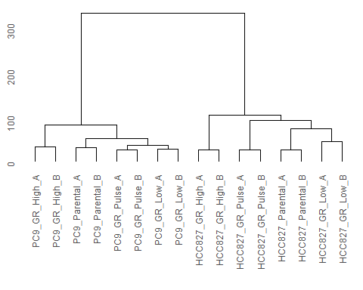
# Principal Component Histogram
# Step 1: Remove genes (rows) with zero variance
counts <- counts[apply( counts, 1, var) != 0, ]
pca_result <- prcomp(t(counts), scale. = TRUE) # Transpose if samples are columns
# Calculate variance explained
var_explained <- pca_result$sdev^2 / sum(pca_result$sdev^2) * 100
# Create Plotly screeplot
counts <- counts[apply(counts, 1, var) != 0, ]
# Perform PCA
pca_result <- prcomp(t(counts), scale. = TRUE)
# Calculate variance explained
var_explained <- pca_result$sdev^2 / sum(pca_result$sdev^2) * 100
# Create a data frame for plotting
scree_df <- data.frame(PC = paste0('PC', 1:length(var_explained)),Variance = var_explained)
# Create ggplot scree plot
ggplot(scree_df, aes(x = PC, y = Variance)) +
geom_bar(stat = 'identity', fill = 'blue') +
geom_text(aes(label = paste0(round(Variance, 2), '%')), vjust = -0.5, size = 3) +
labs(title = 'Principal Component Histogram',x = 'Principal Components', y = 'Variance Explained (%)') +
theme(axis.text.x = element_text(angle = 90, vjust = 0.5, hjust = 1))
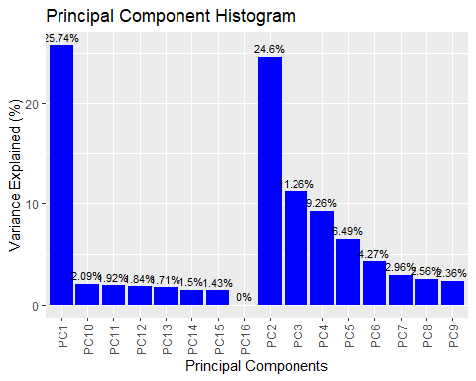
# Principal Component Analysis
x <- counts
# Step 1: Remove genes (rows) with zero variance
x <- x[apply(x, 1, var) != 0, ]
# Step 2: Transpose and run PCA
x_t <- t(x)
pca_result <- prcomp(x_t, scale. = TRUE)
# Step 3: Extract PCA scores
pca_data <- as.data.frame(pca_result$x)
pca_data$Sample <- rownames(pca_data)
# Step 4: Get variance explained for labels
variance_explained <- summary(pca_result)$importance[2, 1:2] * 100
# Step 5: Plotly PCA plot
x_lab <- paste0('PC1 (', round(variance_explained[1], 1), '%)')
y_lab <- paste0('PC2 (', round(variance_explained[2], 1), '%)')
# Step 5: Create PCA scatter plot with ggplot2
ggplot(pca_data, aes(x = PC1, y = PC2, label = Sample)) +
geom_point(color = 'blue', size = 2) +
geom_text(vjust = -0.5, hjust = 0.5, size = 2) +
labs(title = 'PCA: PC1 vs PC2', x = x_lab, y = y_lab) +
theme_minimal()
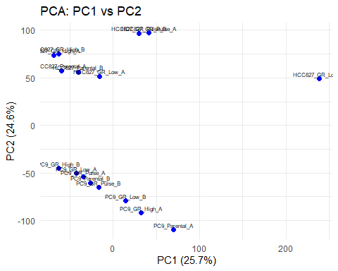
# 3D Principal Component Analysis
library(scatterplot3d)
x <- counts
# Step 1: Remove genes (rows) with zero variance
x <- x[apply(x, 1, var) != 0, ]
# Step 2: Transpose and run PCA
x_t <- t(x)
pca_result <- prcomp(x_t, scale. = TRUE)
# Step 3: Extract PCA scores
pca_data <- as.data.frame(pca_result$x)
pca_data$Sample <- rownames(pca_data)
# Step 4: Get variance explained for labels
variance_explained <- summary(pca_result)$importance[2, 1:2] * 100
s3d <- scatterplot3d(x = pca_data$PC1,y = pca_data$PC2,z = pca_result$ind$coord[, 3],pch = 19,color = 'blue',main = '3D PCA Plot',xlab = 'PC1', ylab = 'PC2', zlab = 'PC3')
coords_2d <- s3d$xyz.convert(x = pca_data$PC1,y = pca_data$PC2,z = pca_result$ind$coord[, 3])
text(x = coords_2d$x, y = coords_2d$y, labels = pca_data$Sample, pos = 3, cex = 0.3)
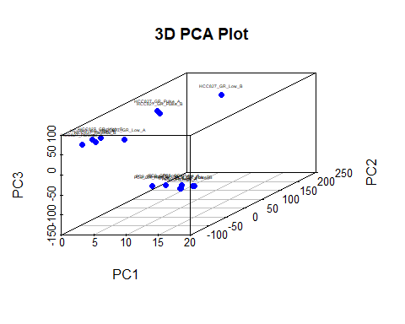
# Violin Plot
data_list <- as.list(as.data.frame(log10(counts + 1)))
vioplot(data_list,col = rainbow(length(data_list)),main = 'Violin Plot',las=2,cex.names=0.5)
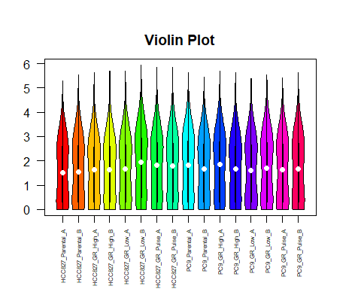
# Density Plot
library(dplyr)
df_list <- lapply(seq_len(ncol(counts)), function(i) {data.frame(counts = counts[, i],idsample = colnames(counts)[i])})
df <- bind_rows(df_list)
df$log_counts <- log10(df$counts + 1)
ggplot(df, aes(x = log_counts, color = idsample)) +
geom_density() +
theme_minimal() +
labs(title = 'Densities', x = 'log(count + 1)', y = 'Density')
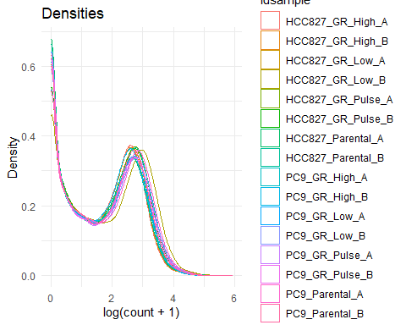
# Heatmap of the 1000 most variable genes
log_counts <- log10(counts + 1)
gene_vars <- apply(counts, 1, var)
top_genes <- names(sort(gene_vars, decreasing = TRUE))[1:1000]
top_counts <- log_counts[top_genes, ]
scaled_counts <- t(scale(t(top_counts)))
heatmap.2(t(scaled_counts),main='Heatmap',scale='col',trace='none', col = colorRampPalette(c('red', 'white', 'blue'))(500),Rowv=NA,cexRow=0.5,cexCol=0.2,dendrogram = 'none',keysize=2.2,margins=c(6,6),cex.main = 0.1)
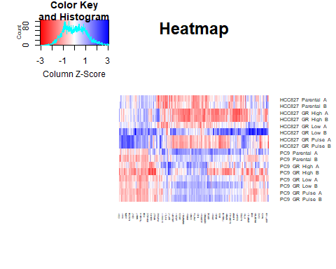
# Volcano
res_df <- res
res_df$significant <- res_df$FDR < 0.05
res_df$gene <- rownames(res_df)
res_df$neg_log10_FDR <- -log10(res_df$FDR)
ggplot(res_df, aes(x = log2FoldChange, y = neg_log10_FDR)) +
geom_point(aes(color = significant), size = 2.5, alpha = 0.6) +
scale_color_manual(values = c('gray', 'red')) +
theme_minimal() +
labs(title = 'Volcano Plot',x = 'log2 Fold Change',y = '-log10 FDR',color = 'Significant') +
theme(plot.title = element_text(size = 16, face = 'bold'),legend.title = element_text(size = 10))
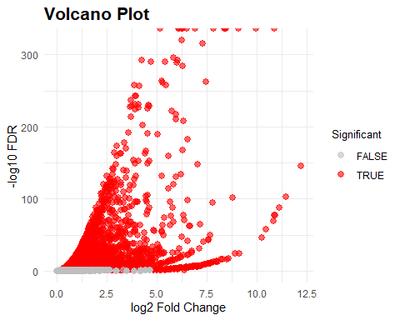
#Log2FoldChange vs logCPM Plot
res_df <- res
res_df$significant <- res_df$FDR < 0.05
res_df$gene <- rownames(res_df)
res_df$neg_log10_FDR <- -log10(res_df$FDR)
ggplot(res_df, aes(x = logCPM, y = log2FoldChange)) +
geom_point(aes(color = significant), size = 2.5, alpha = 0.6) +
scale_color_manual(values = c('gray', 'red')) +
theme_minimal() +
labs(title = 'Log2FoldChange vs logCPM Plot',x = 'logCPM',y = 'log2FoldChange',color = 'Significant') +
theme(plot.title = element_text(size = 16, face = 'bold'),legend.title = element_text(size = 10))
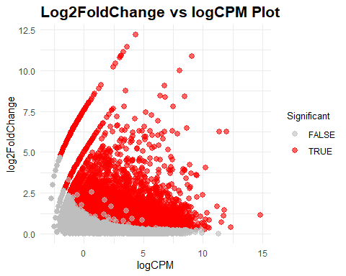
Sys.time()
## [1] "2025-07-17 17:32:52 CEST"
sessionInfo()
## R version 4.5.0 (2025-04-11 ucrt)
## Platform: x86_64-w64-mingw32/x64
## Running under: Windows 10 x64 (build 19045)
##
## Matrix products: default
## LAPACK version 3.12.1
##
## locale:
## [1] LC_COLLATE=English_Germany.utf8 LC_CTYPE=English_Germany.utf8 LC_MONETARY=English_Germany.utf8 LC_NUMERIC=C LC_TIME=English_Germany.utf8
##
## time zone: Europe/Rome
## tzcode source: internal
##
## attached base packages:
## [1] stats4 stats graphics grDevices utils datasets methods base
##
## other attached packages:
## [1] scatterplot3d_0.3-44 janitor_2.2.1 readxl_1.4.5 tinytex_0.57 ggdendro_0.2.0 reshape2_1.4.4 tibble_3.2.1 quantmod_0.4.27
## [9] TTR_0.24.4 xts_0.14.1 DT_0.33 ggrepel_0.9.6 ggraph_2.2.1 plot3D_1.4.1 plotly_4.10.4 factoextra_1.0.7
## [17] FactoMineR_2.11 igraph_2.1.4 dplyr_1.1.4 tidyr_1.3.1 knitr_1.50 stringr_1.5.1 DOSE_4.2.0 enrichplot_1.28.2
## [25] BiocManager_1.30.25 jsonlite_2.0.0 httr_1.4.7 org.Hs.eg.db_3.21.0 clusterProfiler_4.16.0 AnnotationDbi_1.70.0 preprocessCore_1.70.0 vioplot_0.5.1
## [33] zoo_1.8-14 sm_2.2-6.0 edgeR_4.6.2 limma_3.64.0 SummarizedExperiment_1.38.1 Biobase_2.68.0 GenomicRanges_1.60.0 GenomeInfoDb_1.44.0
## [41] IRanges_2.42.0 S4Vectors_0.46.0 BiocGenerics_0.54.0 generics_0.1.4 MatrixGenerics_1.20.0 matrixStats_1.5.0 lattice_0.22-7 mgcv_1.9-3
## [49] nlme_3.1-168 shinythemes_1.2.0 ggplot2_3.5.2 gplots_3.2.0 shinydashboard_0.7.3 markdown_2.0 shiny_1.10.0
##
## loaded via a namespace (and not attached):
## [1] splines_4.5.0 later_1.4.2 bitops_1.0-9 ggplotify_0.1.2 cellranger_1.1.0 R.oo_1.27.1 polyclip_1.10-7 lifecycle_1.0.4 tcltk_4.5.0 MASS_7.3-65
## [11] crosstalk_1.2.1 flashClust_1.01-2 magrittr_2.0.3 rmarkdown_2.29 sass_0.4.10 yaml_2.3.10 jquerylib_0.1.4 httpuv_1.6.16 ggtangle_0.0.6 askpass_1.2.1
## [21] cowplot_1.1.3 DBI_1.2.3 RColorBrewer_1.1-3 lubridate_1.9.4 multcomp_1.4-28 abind_1.4-8 purrr_1.0.4 R.utils_2.13.0 yulab.utils_0.2.0 TH.data_1.1-3
## [31] tweenr_2.0.3 misc3d_0.9-1 sandwich_3.1-1 GenomeInfoDbData_1.2.14 tidytree_0.4.6 commonmark_1.9.5 codetools_0.2-20 DelayedArray_0.34.1 ggforce_0.4.2 tidyselect_1.2.1
## [41] aplot_0.2.5 UCSC.utils_1.4.0 farver_2.1.2 viridis_0.6.5 tidygraph_1.3.1 survival_3.8-3 emmeans_1.11.1 tools_4.5.0 treeio_1.32.0 Rcpp_1.0.14
## [51] glue_1.8.0 gridExtra_2.3 SparseArray_1.8.0 xfun_0.52 qvalue_2.40.0 withr_3.0.2 fastmap_1.2.0 openssl_2.3.2 litedown_0.7 caTools_1.18.3
## [61] digest_0.6.37 timechange_0.3.0 R6_2.6.1 mime_0.13 gridGraphics_0.5-1 estimability_1.5.1 GO.db_3.21.0 gtools_3.9.5 RSQLite_2.3.11 R.methodsS3_1.8.2
## [71] data.table_1.17.2 graphlayouts_1.2.2 htmlwidgets_1.6.4 S4Arrays_1.8.0 pkgconfig_2.0.3 gtable_0.3.6 rsconnect_1.4.1 blob_1.2.4 XVector_0.48.0 htmltools_0.5.8.1
## [81] fgsea_1.34.0 multcompView_0.1-10 scales_1.4.0 leaps_3.2 png_0.1-8 snakecase_0.11.1 ggfun_0.1.8 rstudioapi_0.17.1 curl_6.2.2 cachem_1.1.0
## [91] KernSmooth_2.23-26 parallel_4.5.0 pillar_1.10.2 grid_4.5.0 vctrs_0.6.5 promises_1.3.2 xtable_1.8-4 cluster_2.1.8.1 evaluate_1.0.3 mvtnorm_1.3-3
## [101] cli_3.6.5 locfit_1.5-9.12 compiler_4.5.0 rlang_1.1.6 crayon_1.5.3 labeling_0.4.3 plyr_1.8.9 fs_1.6.6 stringi_1.8.7 viridisLite_0.4.2
## [111] BiocParallel_1.42.0 Biostrings_2.76.0 lazyeval_0.2.2 GOSemSim_2.34.0 Matrix_1.7-3 patchwork_1.3.0 bit64_4.6.0-1 KEGGREST_1.48.0 statmod_1.5.0 fontawesome_0.5.3
## [121] memoise_2.0.1 bslib_0.9.0 ggtree_3.16.0 fastmatch_1.1-6 bit_4.6.0 ape_5.8-1 gson_0.1.0

